Steps to pay your tuition at IIT

There are three different types of students in IIT, full-time, part-time and co-terminal students. They have different demands when they try to pay their tuition. Full-time students care about the financial aid part, such as grant, student loan and scholarship. Part-time students are only concerned about the payment. Co-terminal students hope to see the whole statement because they receive the student loan after the Government check that they have took two undergraduate classes and two graduate classes. That means they can only see the correct balance after the new semester have begun two weeks. In our project, we will design three different financial page according to different demands.

Step 1: login myIIT

Step 2: go to welcome page

Step 3: click the finance tab

Step 4: choose the student type (In real world, when you login, the page will show different page according your username. Now, we just choose the type and go to different page.)

Step 5: show different finance page for different student type

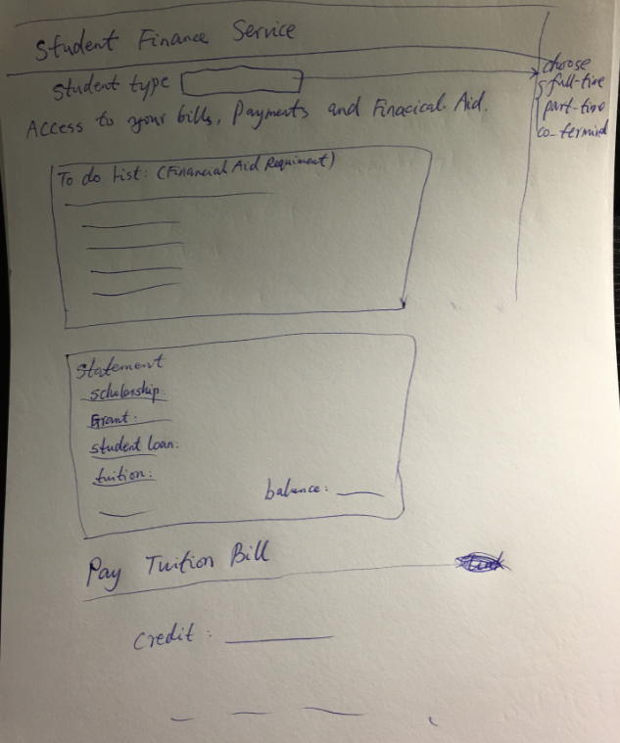

If choosing full-time student, show the default page.

If choosing part-time student, hide the to-do list part.

If choosing co-terminal student, show the different style of statement and show two different balance. One is current balance and the other is the balance if you have accepted the student loan.

Step 6: pay the bill